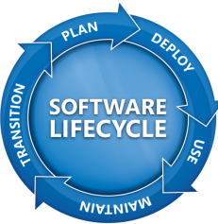
Volume Licensing Service Center
Using Your Software Assurance Benefits:
A Resource Guide

Contents
What are Software Assurance Benefits? 2
Designating a Software Assurance Benefits Manager 2
Benefits available through VLSC 3
24x7 Problem Resolution Support 4
Home Use Program (HUP) 4
What do I need to do to offer HUP to my employees? 4
E-Learning (Systems, Servers, and Applications) 4
Select Courses 5
Distribute Training Codes 5
Learn More 5
Choose a Course 5
Reserve Partner Location 5
Redeem Vouchers 5
Packaged Services 5
Training Vouchers 5
Allocate Courses 6
Learn More 6
Choose a Course 6
Reserve Partner Location 6
Redeem Vouchers 6
TechNet for Software Assurance 6
Designate Chat and Newsgroup Users 6
Identify TechNet Plus Direct Subscriber 7
Activate TechNet Resources 7
Use Extra Training and Support 7
Windows 7 Enterprise 7
Windows Fundamentals for Legacy PCs 7
Office Multi-Language Pack 7
Enterprise Source Licensing Program 8
Employee Purchase Program 8
Benefits from outside VLSC 8
New Product Versions 8
Step-up Licensing 8
Extended Hotfix Support 8
Microsoft Desktop Optimization Pack 9
Cold Back-up for Disaster Recovery 9
Spread Payments 9
Getting Help 9
Tips for getting the most out of your SA Benefits 9

What are Software Assurance Benefits?
Your Software Assurance (SA) Benefits allow you to get the most out of your volume licensing agreement. Benefits may include training, the Microsoft Home Use Program (HUP), and many more.
You can use the Microsoft Volume Licensing Service Center (VLSC) to download licensed products, access product keys, and manage your Volume Licensing agreements and Microsoft Software Assurance benefits.
Note that not all benefits listed will be available to your organization. Sign in to your online account to see which benefits are available to you.
Recent improvements to the VLSC make it easier for you to track your license acquisition activity, agreement benefits, and subscriptions in one online location. As a result of this upgrade, you may need to familiarize yourself with new links and navigational elements. The steps you take to activate and use your Software Assurance Benefits have not changed.
Accessing your SA Benefits begins with designating a Benefits Manager.

Designating a Software Assurance Benefits Manager
A consideration when choosing whether to assign one or more Benefits Manager(s) to manage your benefits is the size of your organization and scope of benefits available to you. An enterprise organization that will access technical, training, and productivity benefits across multiple levels of an organization may find decentralized benefits management most effective, whereas a mid-size organization may find it more efficient to centralize benefits management with one individual or department.
Here are some typical Benefits Manager recommendations for Software Assurance:
SA Benefit | Recommended Manager
- New Products and Deployment Tools (Upgrades, Windows 7 Enterprise Edition, MDOP)  - Deployment Resources (Packaged Services, TechNet)  - Training for IT Staff (Training Vouchers)  - 24x7 Resolution and Extended Hotfix Support | IT Manager
- Training for End-Users (e-Learning)  - Home Use and Employee Purchase Programs | HR Manager

- Steps for the SA Benefits Manager:Ensure that you have administrative rights to activate this benefit, or contact your Notices Contact.
- Browse to the VLSC Web site.
- Click the Sign In button.
- Enter your Windows Live ID credentials. If you do not have a Windows Live ID, click Sign Up Now and follow the instructions on your screen to obtain an ID.
- Click on the Software Assurance menu. This will take you to the Software Assurance Benefits Summary page.
The Software Assurance Benefits Summary includes the total eligible quantity of benefits across all agreements, benefits that have not yet been used, and benefits that have not yet been activated.
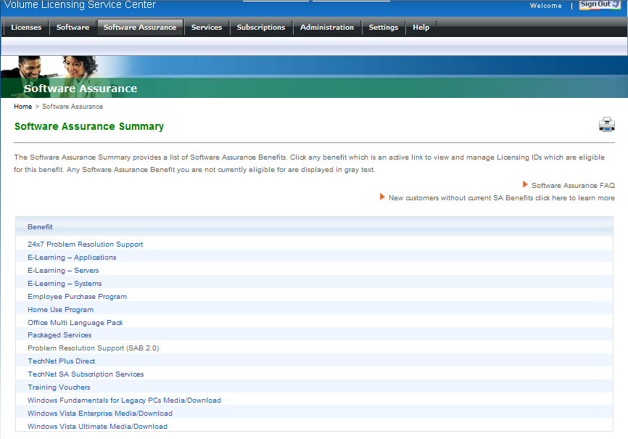
Figure 1. Software Assurance Summary screen. Note that not all benefits may be available to your organization.
Benefits available through VLSC
There are many Software Assurance benefits available to a participant in the Volume Licensing program. Among them are:

24x7 Problem Resolution Support
Around-the-clock phone and web incident support for Microsoft desktop and server products. To access support:
- Click on 24x7 Problem Resolution Support.
- Click on the LicenseID for which you want to manage 24x7 Problem Resolution Support benefits.
- On the next screen, review the Terms and Conditions, then enter your name and click "I Accept" to accept.
- Set up a list of users approved to submit support incidents.

Home Use Program (HUP)
The HUP provides employees with the latest version of Microsoft Office for their home computer, via low cost download.
- Click on Home Use Program.
- Click on the LicenseID for which you want to manage Home Use Program benefits.
- On the next screen, review, and accept the Terms and Conditions.
- To begin using the Home Use Program benefit, you must first provide your contact information and your organization’s domain(s) to ensure authorized use of these benefits. You will receive an email with the Program Code and a link to the Home Use Program order Web site.
- Notify all eligible employees about the program and order instructions.
- Promote this benefit to Human Resources and department managers.

What do I need to do to offer HUP to my employees?
Offering the HUP to your employees is easy. First your organization’s Software Assurance Benefits Manager will need to log into Microsoft Volume Licensing Service Center (VLSC) and activate your Home Use Program benefits. Once activated, your Benefits Manager will get a HUP program code that he or she can send to employees using the emails templates, banner ads or other downloadable marketing resources from HUP.
Employees getting this information will use their HUP program code and work email address to validate their eligibility. Once accepted, they’ll get a confirmation email that allows them make purchases directly through HUP Online Store.

E-Learning (Systems, Servers, and Applications)
Offers self-paced interactive training designed for end-users and IT Professionals, delivered via Internet or Intranet.
- Click on E-Learning.
- Click on the LicenseID for which you want to manage E-Learning benefits.
- Enter contact information and the domain(s) for your organization.
- Click to activate the benefit.
- You will receive an email with a Program Code and a link to the course Web site to distribute to others in your organization.
- Promote this benefit to Human Resources and department managers.
- (tips for multiple users)?

Select Courses
You get a number of select E-Learning courses for a set number of users which varies by product and the type of licenses you have with Software Assurance.
Because they are meant to support the products you purchase, your E-Learning courses match the type of products you have with Software Assurance - meaning if you have Office Enterprise 2007, your E-Learning benefits include courses on Office 2007 products (or applications).
Distribute Training Codes
Your Software Assurance Benefits Manager gets the process started by generating and distributing E-Learning Access codes through the Microsoft VLSC tool and distributing them to users in your organization.

Learn More
To quickly understand how you might use this benefit see more on the benefits of training [4:26].

Choose a Course
To find training that’s right for you, review the current course list. To locate Software Assurance-redeemable classes, be sure to select SA, under Program Type, and select Classroom under Product Type.
Reserve Partner Location
Once you determine the course you want, and find a location that suits you, the CPLS training partner validates your Training Voucher and reserves your classroom spot.
Redeem Vouchers
After you complete your course, the CPLS partner works directly with Microsoft to redeem your Training Voucher and receive payment.

Packaged Services
Provides structured planning services from Microsoft partners to enable efficient deployments, covering Desktop (Office and/or Windows), SharePoint, Exchange, and Business Value Planning Services.
- Click on Packaged Services.
- Click on the LicenseID for which you want to manage Packaged Services benefits.
- Select the voucher types and service level. Note: you may create more than one voucher at a time.
- Assign the Packaged Services voucher to a project manager within your organization.
- The project manager will receive an email message that provides information about the benefit. The email message will also include a link to a list of Microsoft partners or Microsoft Consulting Services so that the project manager can schedule an engagement.
- Promote this benefit to the IT staff within your organization.

Training Vouchers
Provides in-depth technical classroom training for IT professionals and developers.
- Click on Training Vouchers.
- Click on the LicenseID for which you want to manage Training Voucher benefits.
- To begin using the Training Vouchers benefit, you must first create a voucher. To create a voucher, you will need to select the number of days associated with the vouchers and also designate the attendee who will be receiving the voucher and taking the course. The attendee will receive an email with the voucher information and a link to available partners to select from.
- Promote the Training Vouchers benefit to your IT staff, Human Resources department, and those responsible for staff development within your organization.

Allocate Courses
You get a set number of training days from a Microsoft Certified Training Partner (CPLS) that varies by product and the type of licenses you have with Software Assurance.
Because they are designed to help IT Pros and Developers, your Training Vouchers are reserved for technical courses only. Examples of courses include: Implementing Strategies for Microsoft Office Communications Server 2007 R2 and Deploying Microsoft Office Professional Plus 2007.
Assign Course Days
Your Software Assurance Benefits Manager gets the process started by creating Training Vouchers through the Microsoft VLSC tool and distributing them to users in your organization.

Learn More
To quickly understand how you might use this benefit see the course selection and redemption demo and more on the benefits of training [4:26].

Choose a Course
To find training that’s right for you, review the current course list. To locate Software Assurance-redeemable classes, be sure to select SA, under Program Type, and select Classroom under Product Type.
Reserve Partner Location
Once you determine the course you want, and find a location that suits you, the CPLS training partner validates your Training Voucher and reserves your classroom spot.
Redeem Vouchers
After you complete your course, the CPLS partner works directly with Microsoft to redeem your Training Voucher and receive payment.

TechNet for Software Assurance
This benefit gives IT staff access to experts, technical information, plus beta and final versions of products for testing and evaluation.
To access TechNet SA Subscription Services (Chat and Concierge services):

TechNet Plus Direct Subscription
- For TechNet
- Select TechNet Benefits through Software Assurance.
- Click on the LicenseID for which you want to manage TechNet benefits.
- Enter contact information and applicable domains within your organization.
- Click to activate the benefit.
- Promote this benefit to your IT staff and Help Desk.

Designate Chat and Newsgroup Users
TechNet Online Concierge Chat serves as your live, online librarian to help you quickly find relevant resources to plan, implement, and support Microsoft technologies. With TechNet Managed Newsgroups you can post questions to professional peers and receive a guaranteed accurate response. The number of users granted access varies by product and by the type of license you have with SA. Check your SA Benefits to learn more.

Identify TechNet Plus Direct Subscriber
You get a single subscription that gives you full-version commercial software for evaluation, free professional support incidents, exclusive training and technical library, and early beta software.

Activate TechNet Resources
Your SA Benefits Manager uses the VLSC management tool to identify TechNet Subscription benefit participates. Once identified, the TechNet Subscription team sends you your user account details and service information.

Use Extra Training and Support
Your TechNet Plus Direct Subscription gives you access to free, technical E-Learning courses. It also includes two complimentary professional phone support incidents to help you increase uptime and resolve business-critical issues fast.

Windows 7 Enterprise
Helps organizations standardize and reduce security risks with built-in data encryption and multiple language support.
The Windows 7 Enterprise operating system—an exclusive version for midsize and large organizations with Software Assurance—helps customers address challenges such as protecting sensitive data, improving application compatibility, and simplifying IT management and deployment. It includes all of the features of the Windows 7 Professional operating system, along with Windows BitLocker Drive Encryption, four additional virtual operating system licenses to use with Microsoft Virtual PC 2007, a multilingual user interface, and a subsystem for UNIX and Linux-based applications. Your Volume Licensing customers are entitled to one Windows 7 Enterprise license for every Windows desktop operating system license covered by Software Assurance.

Windows Fundamentals for Legacy PCs
Allows continued use of “legacy” PCs—computers running versions of Microsoft Windows prior to Windows 7—while improving their management and security by providing a small-footprint Windows-based operating system solution, designed to work with the Microsoft Remote Desktop Connection client or third-party clients for application access.
- Select Windows Fundamentals for Legacy PCs.
- Click on the LicenseID for which you want to manage Windows Fundamentals for Legacy PCs benefits.
- Enter contact information and media fulfillment preferences.
- Click to activate the benefit.
- Promote this benefit to your IT staff.

Office Multi-Language Pack
Enables IT to deploy a single Office 2010 image with support for 37 languages
- Click on Office Multi Language Pack.
- Click on the LicenseID for which you want to manage the Office Multi Language Pack benefit.
- Do one of the following:
- Choose benefit contact from the list provided, click Add Selected Contact, complete the Benefit Fulfillment section and click on Activate Benefit, or
- Click on Add New, complete the Benefit Contact Detail form, complete the Benefit Fulfillment section and click on Activate Benefit.
- Promote this benefit to your CIO and IT Managers.
- The following Software Assurance benefits are not activated or managed online through Volume Licensing Service Center:

Enterprise Source Licensing Program
Provides access to Microsoft Windows source code for internal development and support.
- Click on Enterprise Source Licensing Program.
- Click on the LicenseID for which you want to manage Enterprise Source Licensing benefits. You will be directed to a page that will inform you how to use the benefit.
- Promote this benefit to IT managers.

Employee Purchase Program
Contributes to employee satisfaction by providing discounts on Microsoft products.
- Click on Employee Purchase Program.
- Click on the LicenseID for which you want to manage Employee Purchase Program benefits.
- On the next screen, review the Terms and Conditions, then enter your name and click "I Accept" to accept.
- To begin using the Employee Purchase Program benefit, you must first provide your contact information and eligible domains within your organization to ensure authorized use of these benefits. You will receive an email with the Program code and a link to the Employee Purchase Program order Web site. You may distribute this to your employees.
- Promote this benefit to Human Resources and department managers.

Benefits from outside VLSC

New Product Versions
Provides new software version releases so you have access to, and own, the latest technology.
Your organization may begin using this benefit on the date your Software Assurance coverage begins. No additional steps are required to activate this benefits.

Step-up Licensing
Enables you to migrate your software from a lower-level edition to a higher-level edition, such as Office Standard to Office Professional, at a low cost.
For more details, ask your Microsoft Account Manager or Partner, or refer to the Microsoft Product List (http://www.microsoftvolumelicensing.com/userights/)

Extended Hotfix Support
This benefit provides specific product fixes on a per customer incident basis, beyond the standard product support terms and releases.
After it is determined, typically by a Support Engineer, that the resolution to a customer-reported issue will likely require a Hotfix for a product in the Extended phase of the support life cycle, contact your Technical Account Manager (TAM). The TAM will work with the appropriate problem resolution team to initiate the process of creating the hotfix. After it is confirmed that a Hotfix can be created and provided to you, the TAM will work with you to sign you up for an Extended Hotfix Support Account (EHSA) or add coverage to your existing EHSA for the affected product.

Microsoft Desktop Optimization Pack
Provides six technologies to help manage PCs and improve application deployments. Includes application virtualization, asset & policy management, and diagnostic tools.
If you are an MDOP customer, you can download MDOP 2009 R2 through Volume License Service Center(details?).

Cold Back-up for Disaster Recovery
Provides licensing for servers used as offline (“cold”) backups, to help improve system availability and protect mission-critical solutions from outages caused by production server downtime.
You need not take any formal action to activate this benefit. Simply use your Microsoft Volume Licensing media (or downloads) to install product on your backup servers. Proof of license and Software Assurance coverage for the production server software and required Client Access Licenses (CALs), are evidence of your right to the cold backup server licenses.

Spread Payments
Payment for License and Software Assurance may be spread across three equal, annual sums.
Your organization may begin using this benefit on the date your Software Assurance coverage begins. No additional steps are required to activate or acquire this benefit.
Getting Help
If you need more help with your Software Assurance Benefits …
Tips for getting the most out of your SA Benefits
Some tips to help you maximize the SA benefits for your organization:
- Evaluate your office’s needs.
- Sign in and review the benefits available to your organization.

