Task 35760485 /hardware-network/controller/get-to-know-your-xbox-series-x-s-controller
Page title | Get to know your Xbox Series X|S Wireless Controller
SEO Description | Get a detailed look at the buttons, triggers, and left and right sticks on your Xbox Series X | S Wireless Controller.
SEO Tags | xbox wireless controller, xbox series x controller, xbox series s controller, xbox wireless controller buttons

Get to know your Xbox Series X|S Wireless Controller
For Xbox Series X|S, we’ve streamlined the Xbox Wireless Controller for comfort, performance, and instant sharing. The controller also works great with Xbox One, Windows 10, and cloud gaming devices.

The face of the controller
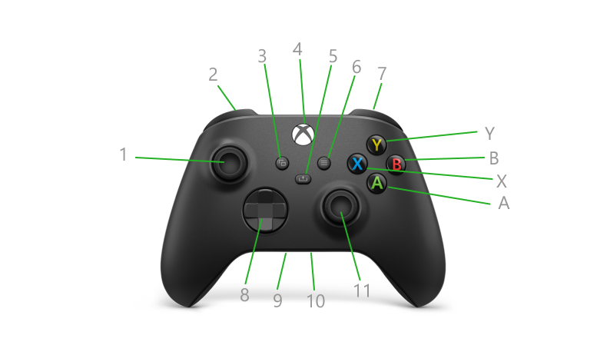
1 Left stick | 9 3.5-mm port
2 Left bumper | 10 Expansion port
3 View button | 11 Right stick
4 Xbox button | X X button
5 Share button | Y Y button
6 Menu button | A A button
7 Right bumper | B B button
8 Directional pad (D-pad)
Left stick (1) and right stick (11): These are small joysticks, raised above the controller surface. The left stick resides on the upper left of the front face of the controller, and the right stick resides on the lower right of the front face. The sticks are used to interact with games, apps, and the Xbox console. These move directionally and they can also function as clickable buttons when you press down on them.
Left bumper (2) and right bumper (7): These oblong-shaped controls reside on the top of the controller to the left and right of the USB-C charging port. They are used to interact with games, apps, and the Xbox console. They are often used to let you jump between sections of the interface but have varied functionality depending on the game.
View button (3): This button resides just to the lower left of the Xbox button. The functions of this button vary depending on the app or game
Xbox button (4): This button resides at the top on the face of the controller. It has multiple functions:
- When the controller is turned off, pressing this button turns on the controller. It will also turn on the console if the console is not already on.
- When the controller is turned on:
  - Pressing this button once will open the guide on the Xbox console. On a Windows 10 PC during game play, this button will open Xbox Game Bar. Exception: During game streaming through the Xbox Console Companion App for Windows 10, pressing this button returns you to the Home screen of the Xbox App.
  - Pressing and holding this button will open the What do you want to do? screen. From there, you can turn off the console or controller, restart the console, or turn on Narrator or Magnifier.
  - Pressing and holding this button for about 6 seconds turns off the controller.
Share button (5): This button resides in the center of the controller’s face directly below the Xbox button. Press this button to capture game clips and screenshots then share them with friends.
Menu button (6): This button resides just to the lower right of the Xbox button. Use this button to access game and app menu options like Settings or Help, along with commands within the user interface such as Enter on a keyboard.
Directional pad (D-pad) (8): This is a raised plus sign-shaped toggle that resides between the left and right sticks. Used to interact with games, apps, and the Xbox console. It moves the focus up, down, right, and left in the interface.
3.5mm port (9): This is a recessed port next to the expansion port on the bottom-side edge of the controller. Used to connect compatible 3.5-mm audio devices.
Expansion port (10): This is a recessed port that resides on the bottom-side edge of the controller. It's used to connect other accessories such as an Xbox One Stereo Headset Adapter.
A, B, X, Y buttons: These buttons reside on the right side of the controller. The Y button sits in the top position, with B on the right, A on the bottom, and X on the left. Used to interact with games, apps, and the console interface.
The back of the controller
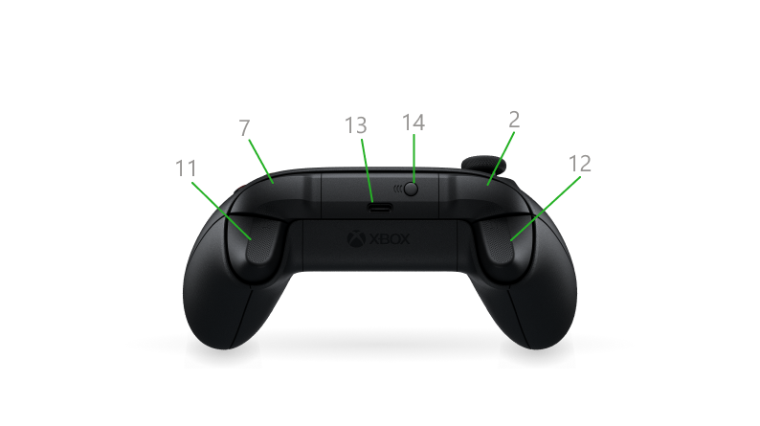
2 Left bumper | 12 Left trigger
7 Right bumper | 13 USB-C power port
11 Right trigger | 14 Pair button
Left bumper (2) and right bumper (7): These oblong-shaped controls reside on the top of the controller to the left and right of the USB charging port. These controls are used to interact with games, apps, and the Xbox console. They are often used to let you jump between sections of the interface but have varied functionality depending on the game.
Right trigger (11) and left trigger (12): Positioned just below the bumpers on the front-top edge of the controller. These are pressable controls are most commonly used during gameplay. They often vibrate to provide feedback during the games, though you can turn off vibration in the controller settings.
USB-C power port (13): The USB-C power port is used for charging your Xbox Series X|S Wireless Controller. This port resides on the top edge of the controller above the Xbox button.
Note Third-party battery packs may not be compatible with this model of controller.
Pair button (14): This small, slightly raised button resides near the USB-C port on the top edge of the controller. It is used to wirelessly connect the controller to Xbox and pair Bluetooth on a Windows 10 PC.
For more info about mapping buttons, see:
Customize an Xbox Wireless Controller

