TASK 51402388 account-profile/accessibility/xbox-adaptive-joystick
PLEASE ENSURE YOUR TRACKED CHANGES IS TURNED ON FOR THIS DOC
Page Title | All about the Xbox Adaptive Joystick
SEO Description | Learn everything you need to know about the Xbox Adaptive Joystick, including hardware components, button mapping, and troubleshooting tips.
Category | Topic  Choose from list | Accessibility gaming | I have a question about Xbox Accessibility options
SEO Tags/Keywords | Xbox joystick, adaptive joystick, adaptive stick, one-handed joystick, one-handed stick
Endpoint tags | SXC, console
Add to SXC browse? If so, where? | Account & profile / Accessibility  Accessible gaming hub page (TBD)  Hardware & network / Accessories?
Pin on console TOC? | Yes
Stakeholder approval needed? | Yes
Related topics | Play your way with the Xbox Adaptive Controller  Getting started with the Xbox Adaptive Controller  Accessible gaming on Xbox and Windows

All about the Xbox Adaptive Joystick

Introducing the Xbox Adaptive Joystick – a, versatile, one-handed wired joystick designed for players with limited mobility. Connect it to the Xbox Adaptive Controller for a full adaptive setup. Or, connect it directly to your console or PC and pair it with another Xbox controller using Xbox Controller Assist (formerly Xbox Copilot) for full controller functionality. Customize with button remapping, create multiple controller profiles, and switch between profiles – all with the Xbox Accessories app. Explore our guide to set up your joystick and discover different ways to play.
Important Your Xbox Adaptive Controller and Xbox Adaptive Joystick need to be on the latest firmware update before you start using or customizing your device. Find steps on how to update your joystick in the section below.
To update your controller, go to:
Update the Xbox Adaptive Controller
Watch the Getting Started video or, if you prefer, read the following text containing the same information to learn more about the Xbox Adaptive Joystick.

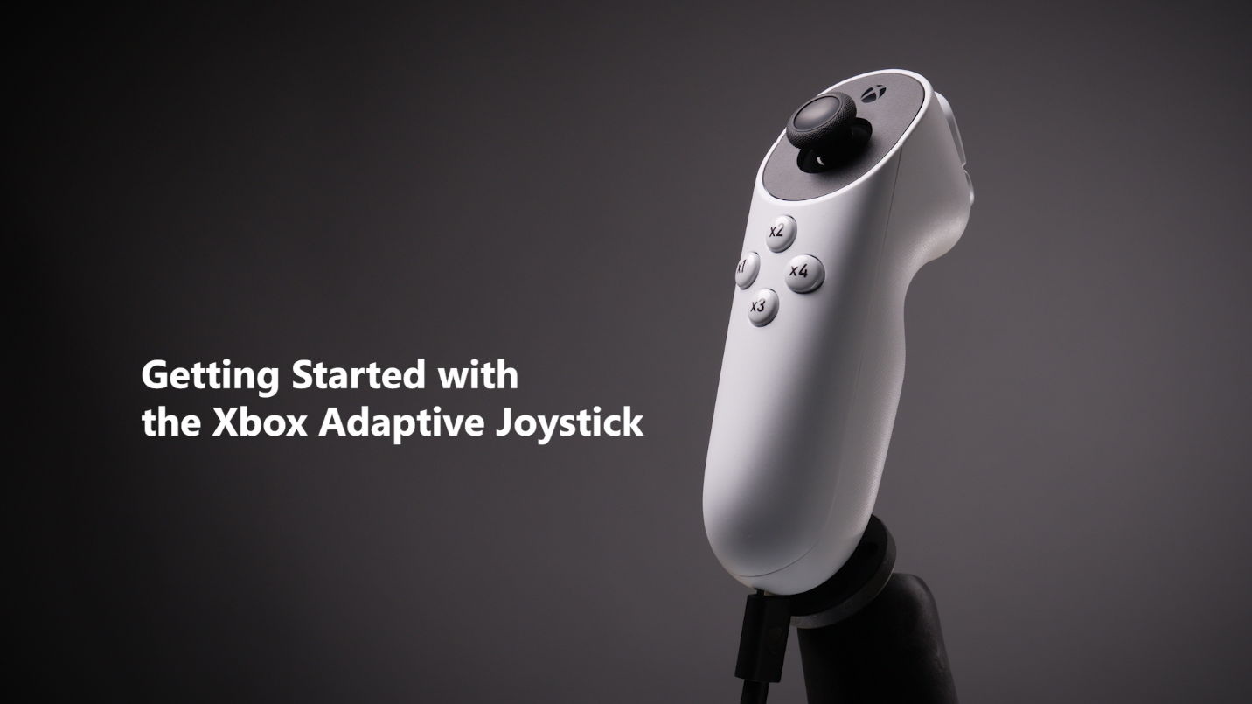
Watch the video (English only)

Get to know the Xbox Adaptive Joystick

How do I connect the Xbox Adaptive Joystick?
To get started, plug the joystick into the Xbox Adaptive Controller’s left or right USB port to create a full adaptive setup.
The Xbox Adaptive Joystick also works without the Xbox Adaptive Controller and can be connected directly to an Xbox console or a Windows PC via USB cable.
Note The Xbox Adaptive Joystick does not have Power, Menu, or View buttons, so it’s recommended that you have another controller (standard, Elite, or Adaptive) connected using the Xbox Controller Assist (formerly Xbox Copilot) feature alongside your joystick. This gives you a means to access all functions on a controller when you need them.

Xbox Adaptive Joystick features
- USB-C port: The joystick has a USB-C port. Use the cable included with the joystick to connect to other devices, such as the Xbox Adaptive Controller, console or PC via wired connection.
Note The Xbox Adaptive Joystick will only work with the Xbox Adaptive Controller, Xbox console, and PC using a wired connection. It is not a wireless device.
- Threaded insert: The joystick features a ¼”-20 threaded mount, allowing you to mount it to suit your needs. This is a standard size used by many tripod camera mounts.
Note If purchasing an accessory to mount the controller, keep in mind that sturdiness and stability should be taken into consideration. RAM Mounts Tough-Claw is one example of a mount, however, there are many different manufacturers that sell ¼"-20 mounts with varying price points.
RAM Mounts Tough-Claw
- Joystick buttons: The diagram below details the buttons available on the Xbox Adaptive Joystick along with their default mappings. The stick also functions as a clickable button when you press down on it.
  - The force required to press these buttons are as follows:
    - x1 – x4:
    - x5:
    - x6:
    - Stick Click:

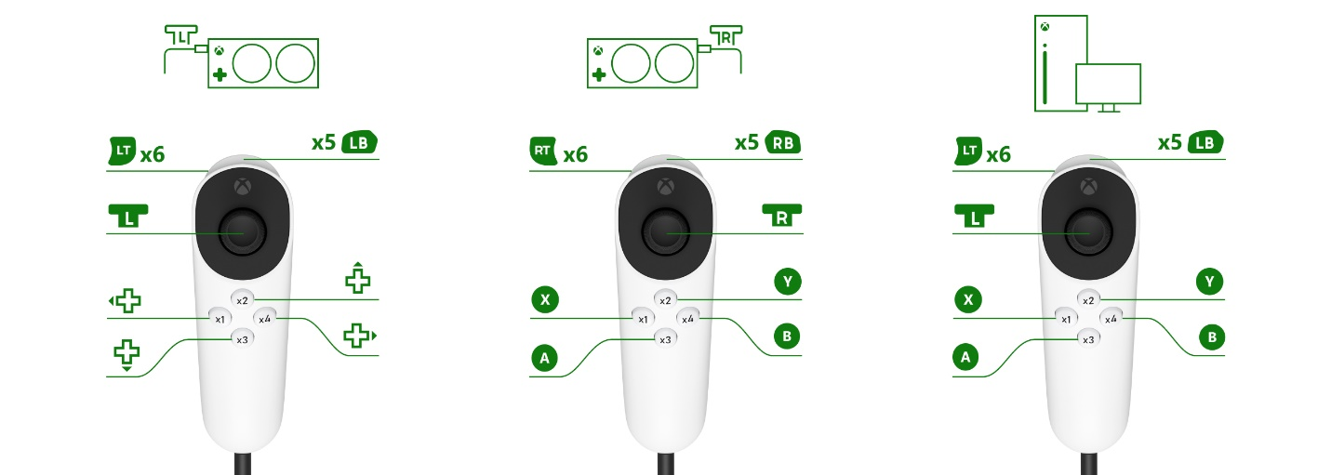
Note Make sure that your Xbox Adaptive Joystick and Xbox Adaptive Controller firmware have the latest updates. If not, default mappings may differ from what is pictured above.
While the buttons on the Xbox Adaptive Joystick can be mapped to the left or right trigger, they do not function as variable triggers. For example, when pressing a joystick button assigned to the left trigger, the button press is the equivalent of 100% of a trigger pull, or as though the trigger is being held all the way down.
For more details on setting up your joystick, refer to our quick start guide:
Xbox Adaptive Joystick quick start guide

Update your Xbox Adaptive Joystick

Update on your console
In order to update your Xbox Adaptive Joystick, it must be plugged directly into one of your console's USB ports. If using your device with an Xbox Adaptive Controller, unplug it from your controller first and connect it directly to your console.
- Press the Xbox button to open the guide.
- Go to My games & apps > See all.
- Open the Xbox Accessories app.
- Select Xbox Adaptive Joystick > More options (…) > Update now. The console will tell you if no update is available.

Update on your PC
In order to update your Xbox Adaptive Joystick, it must be plugged directly into one of your PC’s USB ports. If using your device with an Xbox Adaptive Controller, unplug it from your controller first and connect it directly to your console.
- Plug your Xbox Adaptive Joystick directly into a USB port on your PC.
- Start the Xbox Accessories App for PC.
- Select Xbox Adaptive Joystick > More options (…) > Update now.

Customize your Xbox Adaptive Joystick

Remap your joystick as part of an Xbox Adaptive Controller setup

Mapping buttons and inputs
Important Both your Xbox Adaptive Joystick and your Xbox Adaptive Controller must have the latest available updates in order to configure your joystick using the steps that follow. To update your Xbox Adaptive Joystick, see the section “Update your Xbox Adaptive Joystick” above.
To remap the joystick when connected to the Xbox Adaptive Controller, go to My games & apps and open the Xbox Accessories app. Select Xbox Adaptive Controller > Configure > New profile.
Add image
Once you’ve created your profile, assign it to slot 1, 2, or 3 on your Xbox Adaptive Controller and press the change profile button on your controller to start using it.
Things to keep in mind
- Remapping the assignment of a button on the Xbox Adaptive Joystick will also remap buttons or ports on the Xbox Adaptive Controller with the same default assignment. For example, remapping the joystick’s default A button (mapped to x3) to X will also remap the large A button on the face of the adaptive controller and its A port to X. This will be transferred to the profile configuration screen in the Xbox Accessories app to easily keep track of.
- User profiles created and stored on the Xbox Adaptive Controller are independent from profiles stored on the Xbox Adaptive Joystick. For example, if a button on the adaptive joystick is remapped when connected directly to console or PC, that remapping will not be automatically transferred when connecting the Xbox Adaptive Joystick to an Xbox Adaptive Controller (and vice versa).
To remap a button or input to have it perform a function other than its default function:
- Open the Xbox Accessories app.
- Scroll to your Xbox Adaptive Controller and select Configure.
- Select a profile to adjust or create a new one.
- Select the Edit button and in the Mapping tab select the icon or letter for the button or input you’d like to change.
- Select the function to remap the button to.
- Select Ok to confirm the change.
The mapping screen will now show the button or input with two icons or letters, one above the other. The top icon or letter represents the new primary function, while the bottom icon or letter is the current mapping of the Shift function for that button or input.
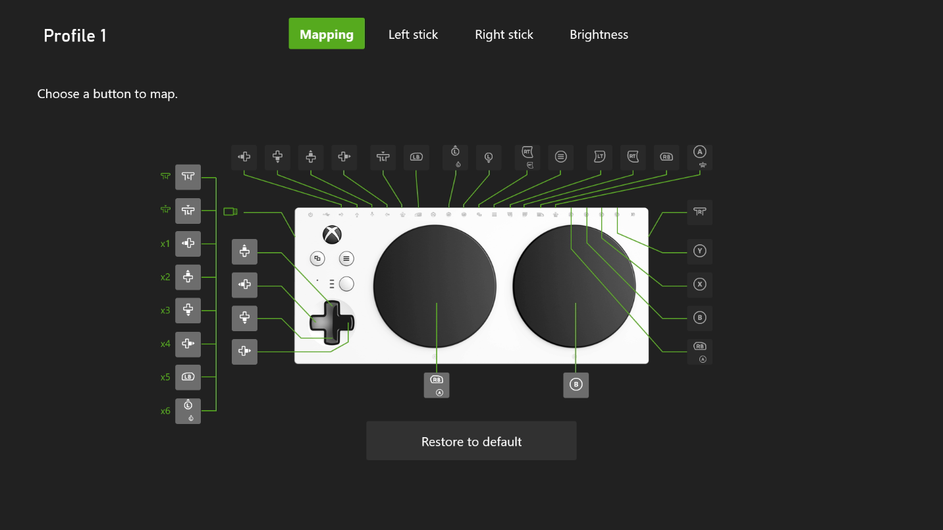

Other remapping features

Assigning Shift controls
Assign a button to act as a “Shift key”. Alternate inputs for your buttons are activated when the assigned Shift button is held down (helpful for changing configurations on the fly).

- Choose the Xbox Adaptive Controller from the list of accessories, and then select Configure.
- Choose a profile to edit or create a new profile.
- Select the Edit icon, and then from the Mapping tab, assign a Shift button by choosing a button and then selecting the Use as Shift button checkbox.
  - For sticks, choose left or right stick, then choose Shift. To swap your left stick with the right stick when modifying with Shift (or vice versa), select the Swap X axis with left/right stick and Swap Y axis with left/right stick checkboxes. To invert the up/down direction of your stick when modifying with Shift, select the Invert Y axis checkbox. When you’re done, press the B button .
  - For buttons, choose a button on the controller you want to modify with Shift, then choose Shift. Choose a button from the list (this will be the button that’s used when the Shift button is held down). The Shift status will reflect the button you’ve chosen. When you’re done, press the B button .

Note Your designated shift button can be a button on your Xbox Adaptive Joystick or on your Xbox Adaptive Controller. Pressing the shift button will put both the adaptive joystick and adaptive controller into “shift” mode when held down.

- Back out of the screen with the B button  to save your change. (The up arrow icon will appear over the button, indicating that it’s the assigned Shift button.)

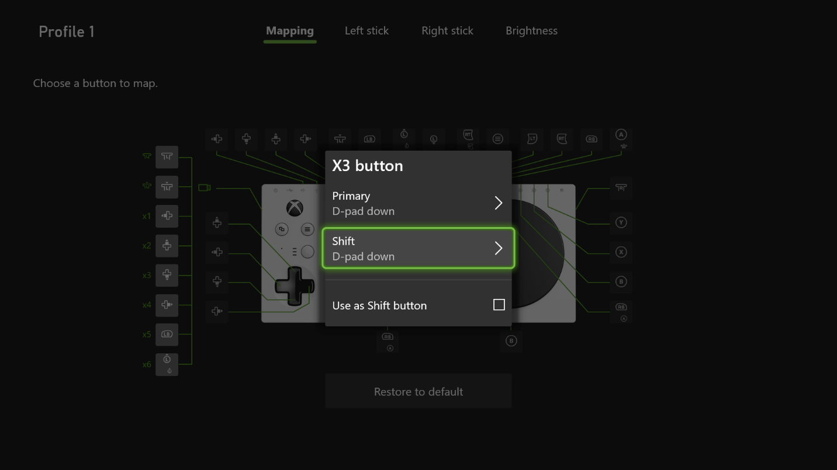

Mapping buttons to keyboard keys
- Open the Xbox Accessories app.
- Scroll to your Xbox Adaptive Controller and select Configure.
- Select a profile to adjust or create a new one.
- Select the Edit button and in the Mapping tab select the icon or letter for the button or input you’d like to change.
Select Primary and in the pop-up menu select the Key tab.
In this menu you can remap a single keyboard key with as many of the listed modifier keys as you want. Use Assign a key to choose the keyboard key you want mapped to the controller button or input and then select as many of the modifier key checkboxes as desired for the following: Shift, Ctrl, Alt, Win.
Note The Shift modifier here is not the same as the Shift function available elsewhere in the Accessories app.
Another way to choose a key and assign it is to select Show all. This will list all possible keyboard keys where a key can then be chosen.
After remapping, the mapping screen will now show the button or input with two icons or letters, one above the other. The top icon or letter represents the new primary function, while the bottom icon or letter is the current mapping of the Shift function for that button or input.
Things to keep in mind:
- On a Windows PC, buttons mapped to keyboard keys will only work when the controller is connected over via USB cable or with the Xbox Wireless Adapter.
- Keyboard key support depends on the game.
- Remapped buttons apply only to the controller that remaps these settings. They do not translate to other controllers if you’re using the Xbox Controller Assist feature (formerly known as Xbox Copilot).
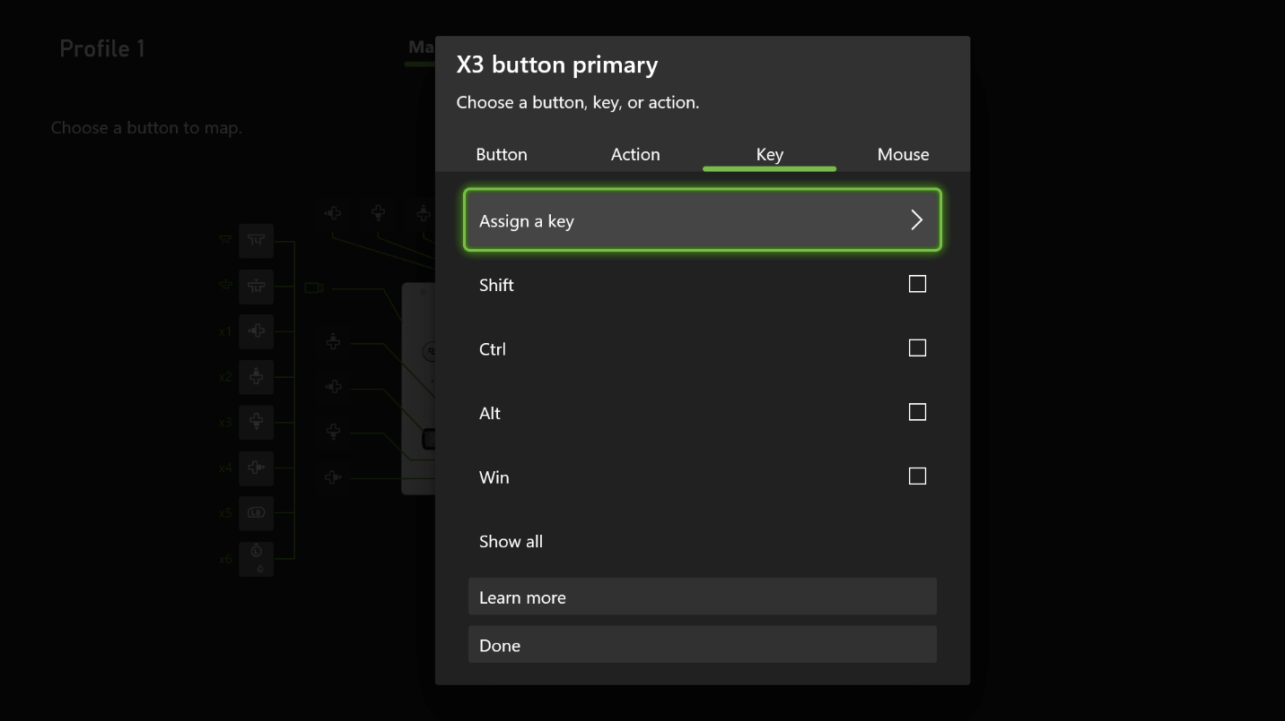

Mapping stick to mouse movements
To map the movement of one of the sticks to a mouse cursor when connected to your adaptive controller:
- Open the Xbox Accessories app on Windows PC.
- Choose your Xbox Adaptive Controller from the list of accessories, and then select Configure.
- Choose a profile to edit or create a new profile.
- Select Edit, and then from the Mapping tab select the stick icon on your Xbox Adaptive Joystick.
- Select Primary, and then choose Mouse from the Use as dropdown.
Note This feature is only available over USB on PC.
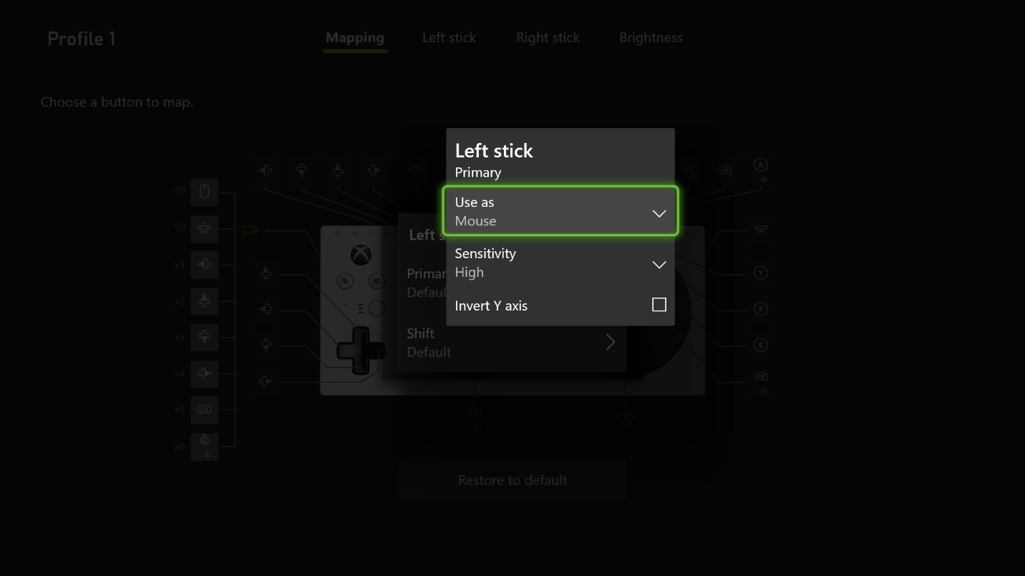

Mapping stick directionals to buttons
You can map the movement of the external joysticks that are connected to your Xbox Adaptive Controller in one of four cardinal directions to the equivalent of a button press. To do so:
- Open the Xbox Accessories app.
- Choose your Xbox Adaptive Controller from the list of accessories, and then select Configure.
- Choose a profile to edit or create a new profile.
- Select Edit, and then from the Mapping tab select the stick icon on your Xbox Adaptive Joystick.
- Select Primary, and then choose Buttons from the Use as dropdown.
- Back out to the Mapping tab, and then select the cardinal directions that you want to remap.
Note If you don’t map these buttons, the setting will revert to Stick.

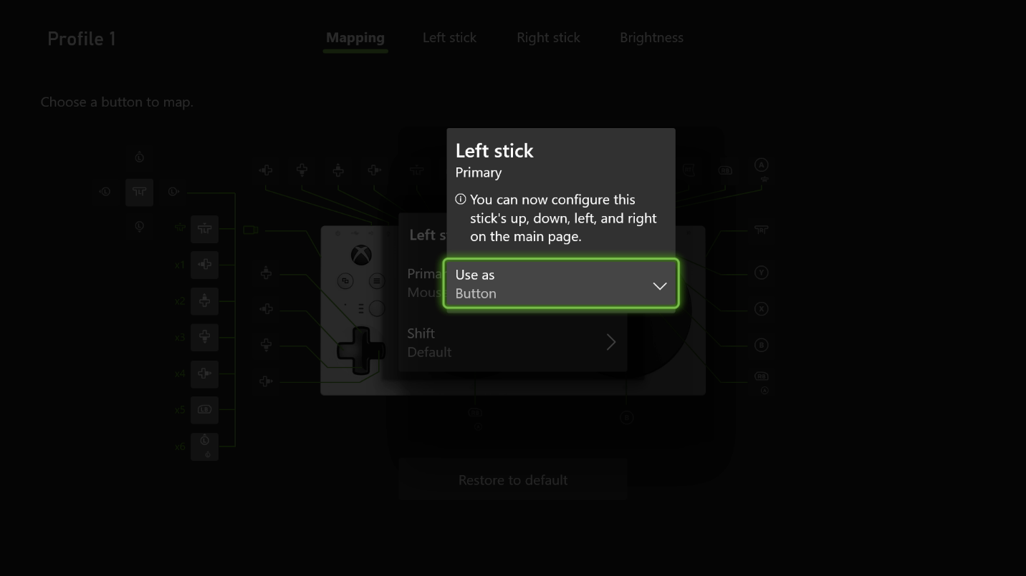
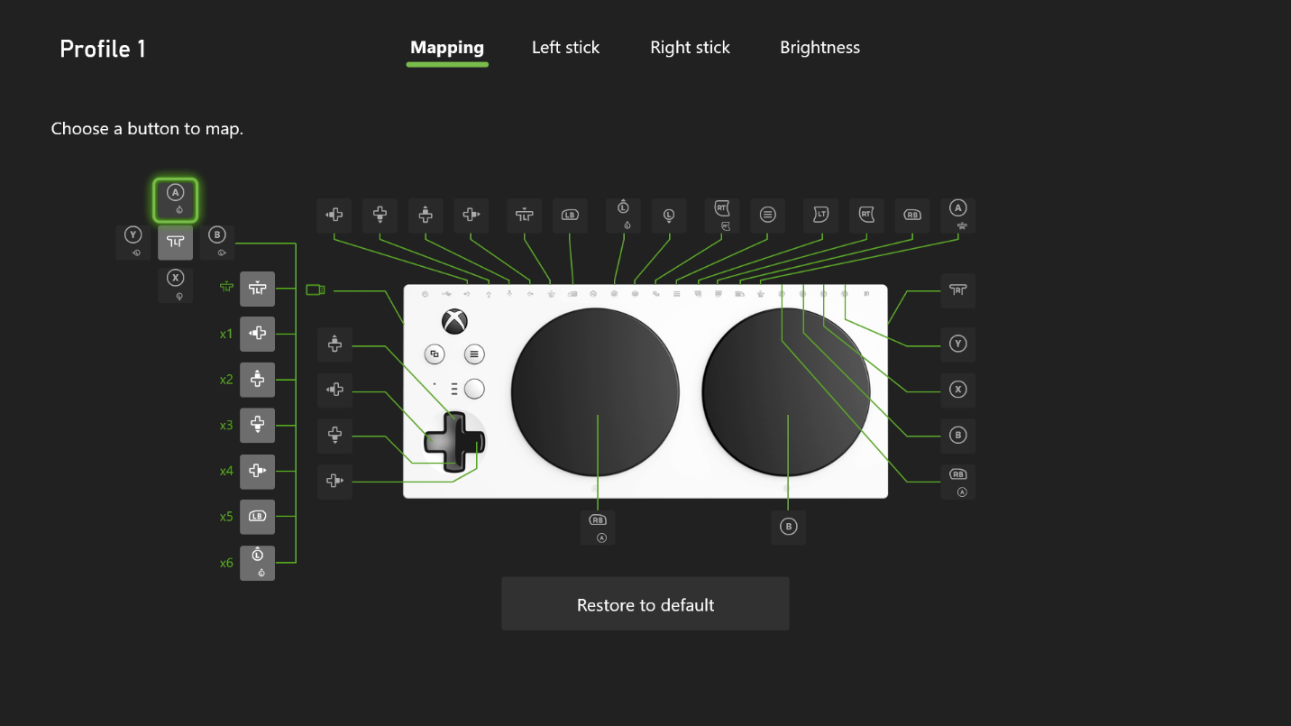

Unmapping buttons
In the same way you can change the function of a button to a different function, you can also unmap, or disable, a button. Meaning, when the button is pressed, it will not provide any input to the console or PC. This can be helpful if you are accidentally activating buttons due to their physical location.

To unmap a button or input:
- Open the Xbox Accessories app.
- Scroll to your Xbox Adaptive Controlller and select Configure.
- Select a profile to adjust or create a new one.
- Select the Edit button and in the Mapping tab select the icon or letter for the button or input you’d like to change.
- Select Primary and in the pop-up menu select a tab to see what functions are available.
- Select the Unmapped function from the list.
- Select Ok to confirm the change.
The mapping screen will now show a dash where the primary function is typically displayed, indicating the button has been unmapped.
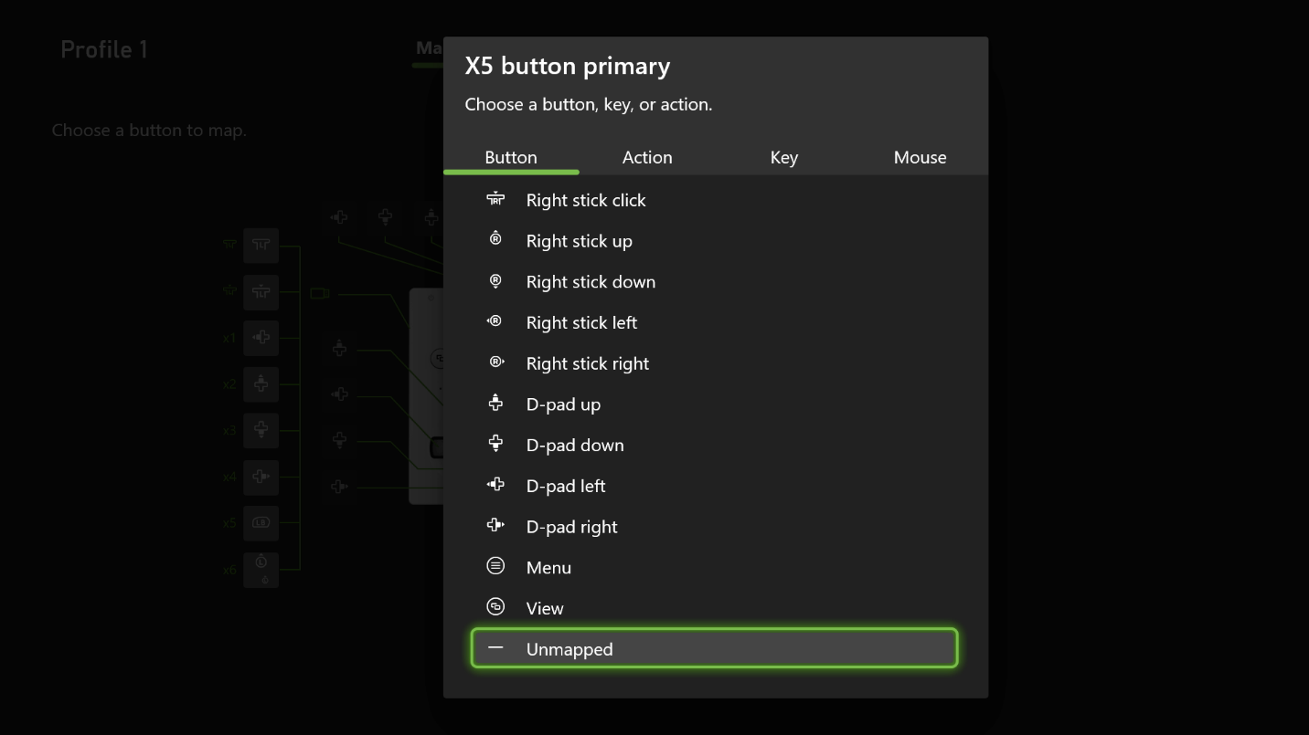

Adjusting stick sensitivity

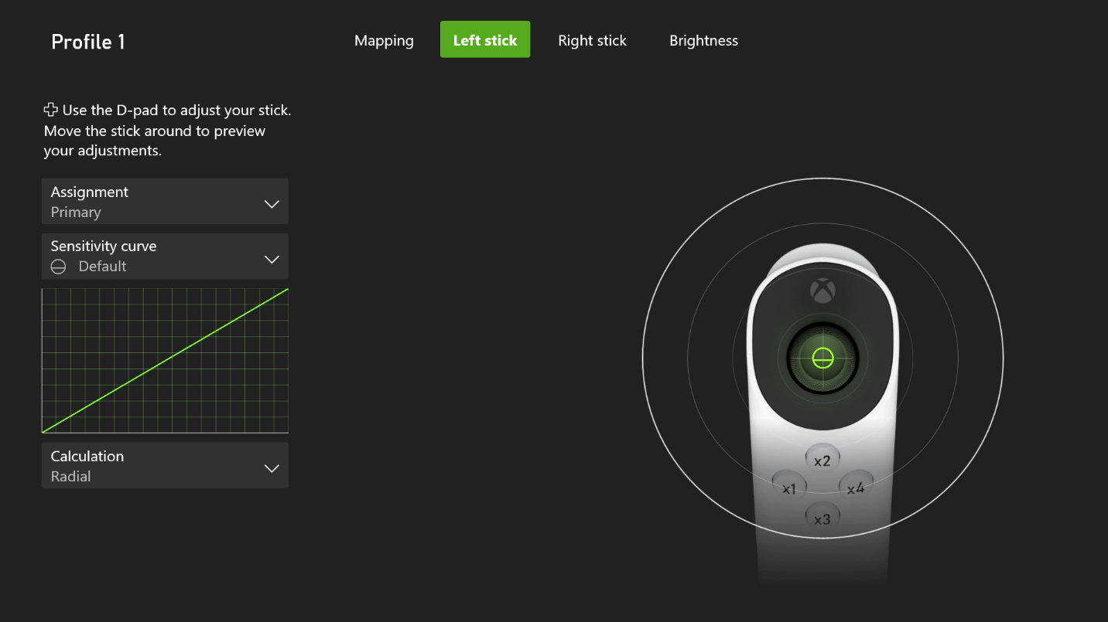
Using the Xbox Accessories app, you can adjust the sensitivity of the stick on your Xbox Adaptive Controller. There are five presets, and each one is customizable (except Default):
- Default: This is the default setting.
- Delayed: Makes the stick take longer to react to your movement.
- Aggressive: Makes the stick react quicker to your movement.
- Instant: A quicker reaction that will then slow down.
- Smooth: Starts out quick, then slows down before movement picks up speed again.
To change the sensitivity:
- Open the Xbox Accessories app.
- Scroll to your Xbox Adaptive Controller and select Configure.
- Select a profile to adjust or create a new one.
- Select the Edit button and in the Left stick or Right stick tab, select one of the sensitivity presets.
- Curve adjustment allows you to adjust the curve itself.
- Calculation lets you adjust how far the stick must go to activate its action. Choose from Radial, Axis-independent, and True diagonals.
For more info about controller stick settings, visit:
Adjusting the controller stick settings in the Xbox Accessories app

Remap your joystick when connected directly to your console or PC

Mapping buttons and inputs
Important Both your Xbox Adaptive Joystick and your Xbox Adaptive Controller must have the latest available updates in order to configure your joystick using the steps that follow. To update your Xbox Adaptive Joystick, see the section “Update your Xbox Adaptive Joystick” above.
To remap the joystick when connected directly to your console, go to My games & apps and open the Xbox Accessories app. Select Xbox Adaptive Joystick > Configure > New Profile.
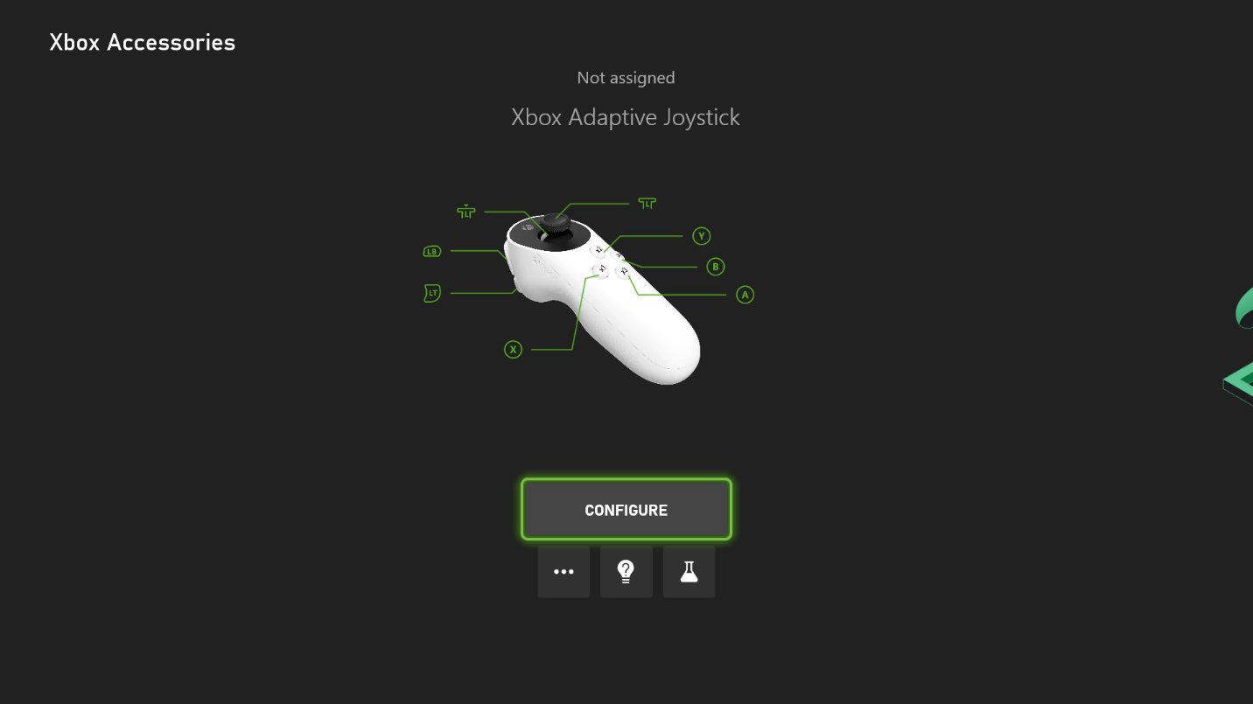
Note You can only assign one custom profile to the Xbox Adaptive Joystick at a time when connected directly to your console or PC. Once you’ve created your profile, assign it to slot 1 to start using it.
When connected directly to your console or PC, you can configure the same functions listed above when connected to your Xbox Adaptive Joystick, as well as the following additional functionalities:

Other remapping features

Mapping toggle holds
You can enable toggle holds for any button or port on the Xbox Adaptive Controller.
Like Sticky Keys on a keyboard, when a toggle hold is enabled, the button will stay pressed virtually upon pressing it once. When you press the button again, it will release the input.
To assign a toggle hold:
- Create a profile or edit an existing one.
- Select the button you’d like to assign a toggle hold.
- Select Enable toggle hold for Primary or Enable Toggle hold for shift depending on which function you want toggled.
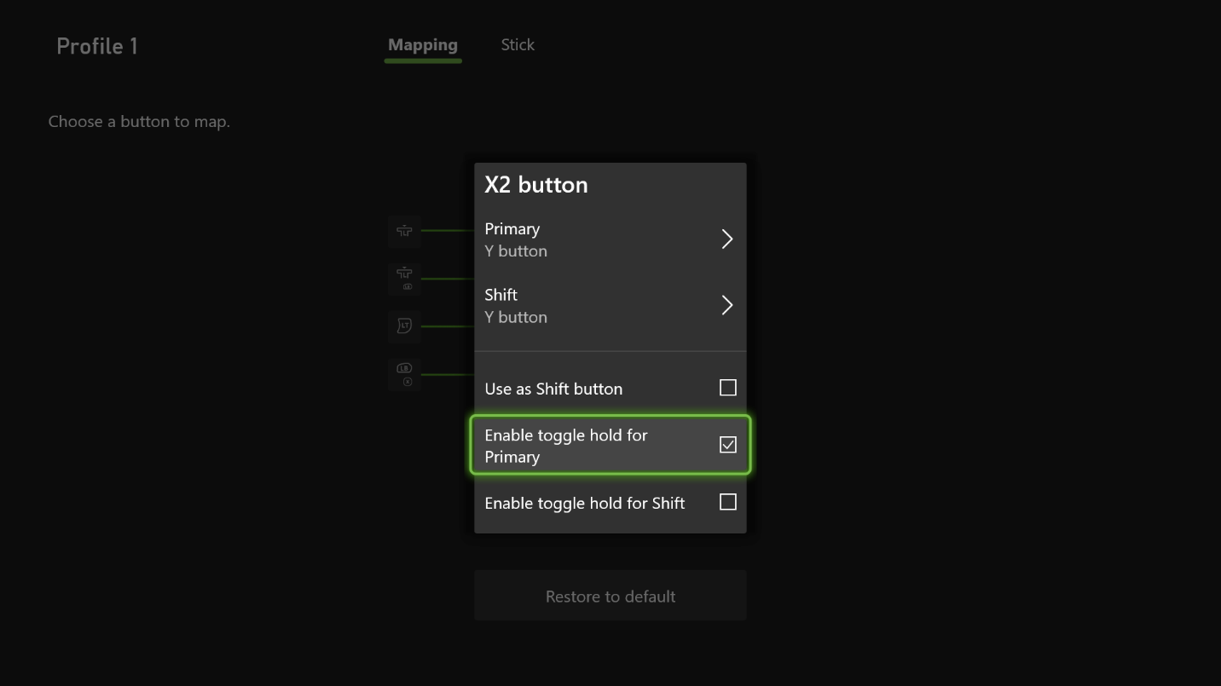

Name your joystick
If using two adaptive joysticks at the same time, it can be helpful to name your joysticks to differentiate one from the other.
To name your joystick in the Xbox Accessories app on console or PC, select Xbox Adaptive Joystick > More options > Rename
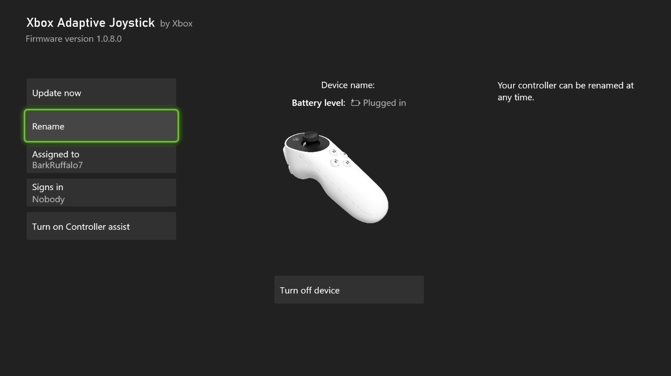

Turn off your joystick
To turn off your Xbox Adaptive Joystick, you can either disconnect the power cable from the device, or use the Xbox Accessories App on console or PC. Select Xbox Adaptive Joystick > More options > Turn off Device

Note The Turn off joystick button will only appear on console. It is not supported on PC.

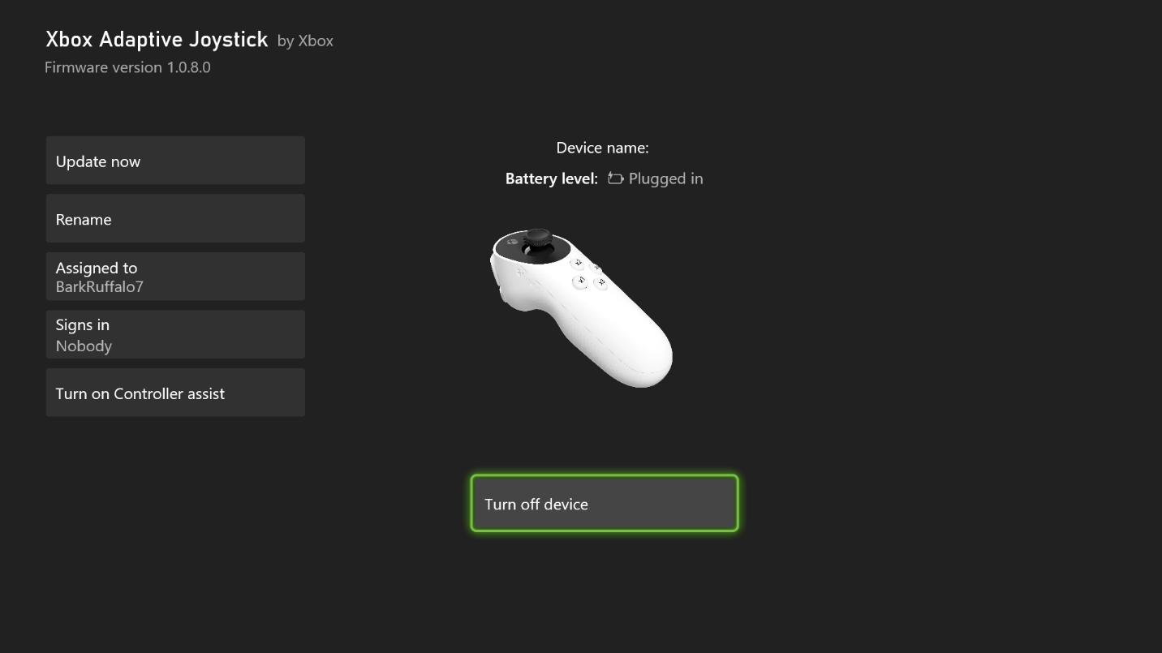

Customize the Xbox Adaptive Joystick with Xbox Adaptive Thumbstick toppers
You can further customize your Xbox Adaptive Joystick using 3D-printed toppers that can be created in the Xbox Design Lab for printing on a 3D printer or through a 3D printing service. For more information, go to:
Guide for printing adaptive toppers from Xbox Design Lab
Troubleshoot the Xbox Adaptive Joystick

The button functionalities on my Xbox Adaptive Joystick do not match the quick start guide
Make sure that the firmware for the Xbox Adaptive Joystick and the Xbox Adaptive Controller are from the latest build.

The Xbox Accessories app isn’t showing the Xbox Adaptive Joystick remapping interface
Make sure that the firmware for the Xbox Adaptive Joystick and the Xbox Adaptive Controller are from the latest firmware build.

The Xbox Adaptive Joystick won’t update using the Xbox Adaptive Controller
To update, you need to unplug the joystick from the Xbox Adaptive Controller and plug it directly into a USB port on your Xbox console or Windows PC.

How do I pair my Xbox Adaptive Joystick with my console?
Unfortunately, you can’t pair the joystick, as it’s solely a wired connection.

Why are button mappings on my Xbox Adaptive Controller automatically changing when I remap my joystick’s buttons?
Remapping the assignment of a button on the Xbox Adaptive Joystick will also remap buttons or ports on the Xbox Adaptive Controller that share the same default assignment. These changes will automatically be transferred in the Xbox Accessories App remapping UI.

Why can’t I assign toggle holds to the buttons on my adaptive joystick when it is connected to my adaptive controller?
At this time, toggle holds are only supported on the Xbox Adaptive Joystick when it is connected directly to your console or PC. If you’d like to assign toggle holds for the buttons on your joystick while also using an adaptive controller, you can connect your joystick directly to your console or PC via USB cable, and then link it with your Xbox Adaptive Controller using Xbox Controller Assist (formerly Xbox Copilot).

